Dynamic response of an RC beam to a drop weight impact (steel ball)
Ball mass - $M_{s}=2.1 \text{t}$
Ball material - steel
Modulus of elasticity - $E_{s}=206 \text{GPa}$
Poisson′s ratio - $ν_{s}=0.3$
Mass density - $ρ_{s}=7.85\frac{ \text{t}}{{ \text{m}}^{3}}$
Ball volume - $V_{s}=\frac{M_{s}}{ρ_{s}}=\frac{2.1 \text{t}}{7.85 \text{t}/{ \text{m}}^{3}}=0.268{ \text{m}}^{3}$ = 4/3πR³
Ball radius - $R_{s}=\sqrt[3]{\frac{3}{4}·\frac{V_{s}}{π}}=\sqrt[3]{\frac{3}{4}·\frac{0.268{ \text{m}}^{3}}{3.14}}=400 \text{mm}$
Height of bottom above the beam surface - $H=2 \text{m}$
Structure type - simply supported beam
Beam length - $L=12 \text{m}$
Material - reinforced concrete C20/25
Modulus of elasticity - $E=20 \text{GPa}$
Poisson′s ratio - $ν=0.2$
Shear modulus - $G=\frac{E}{2·\left(1+ν\right)}=\frac{20 \text{GPa}}{2·\left(1+0.2\right)}=8.33 \text{GPa}$
Unit weight - $γ_{b}=25\frac{ \text{kN}}{{ \text{m}}^{3}}$
Cross section - rectangular with dimensions:
Width - $b=350 \text{mm}$
Height - $h=650 \text{mm}$
Area - $A=b·h=350 \text{mm}·650 \text{mm}=2275{ \text{cm}}^{2}$
Second moment of area - $I=\frac{b·h^{3}}{12}=\frac{350 \text{mm}·{\left(650 \text{mm}\right)}^{3}}{12}=8009895833{ \text{mm}}^{4}$
Shear area - $A_{Q}=\frac{5}{6}·A=\frac{5}{6}·2275{ \text{cm}}^{2}=1895.83{ \text{cm}}^{2}$
Self-weight - $g_{b}=A·γ_{b}=2275{ \text{cm}}^{2}·25 \text{kN}/{ \text{m}}^{3}=5.69 \text{kN}/\text{m}$
Uniform load - $q=10\frac{ \text{kN}}{ \text{m}}$
Gravity acceleration - $g=9.81\frac{ \text{m}}{{ \text{s}}^{2}}$
Uniform mass - $m=\frac{g_{b}+q}{g}=\frac{5.69 \text{kN}/ \text{m}+10 \text{kN}/ \text{m}}{9.81 \text{m}/{ \text{s}}^{2}}=1.6 \text{t}/\text{m}$
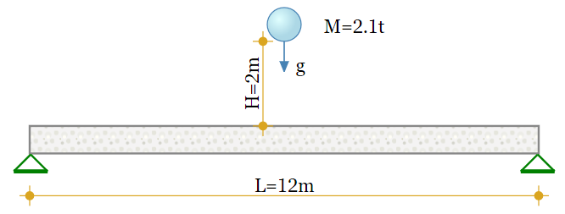
Simple analytical solution
The structure is reduced to a SDOF system for simplicity
Dynamically equivalent mass - $M_{d}=\frac{2·L}{π}·m=\frac{2·12 \text{m}}{3.14}·1.6 \text{t}/\text{m}=12.22 \text{t}$
Potential energy of the ball before dropping
$$E_{p}=M_{s}·g·H=2.1 \text{t}·9.81 \text{m}/{ \text{s}}^{2}·2 \text{m}=41.28 \text{kJ}$$
Kinetic energy immediately before the impact - $E_{k}=\frac{M_{s}·{v_{0}}^{2}}{2}$
The velocity at the moment before the impact is determined by the energy conservation law $E_{k}=E_{p}$ :
$$v_{0}=\sqrt{\frac{2·E_{p}}{M_{s}}}=\sqrt{\frac{2·41.28 \text{kJ}}{2.1 \text{t}}}=6.26 \text{m}/\text{s}$$
Perfectly inelastic collision model is assumed.
Total mass after contact - $M_{tot}=M_{s}+M_{d}=2.1 \text{t}+12.22 \text{t}=14.33 \text{t}$
The velocity immediately after the contact is determined by the law of conservation of momentum:
$$v_{1}=\frac{v_{0}·M_{s}}{M_{tot}}=\frac{6.26 \text{m}/ \text{s}·2.1 \text{t}}{14.33 \text{t}}=0.92 \text{m}/\text{s}$$
Structural stiffness for a vertical force applied at the middle point of the span
$$K=\frac{48·E·I}{L^{3}}=\frac{48·20 \text{GPa}·8009895833{ \text{mm}}^{4}}{{\left(12 \text{m}\right)}^{3}}=4449.94 \text{kN}/\text{m}$$
Deflection due to uniform load
$$z_{0}=\frac{5·\left(g_{b}+q\right)·L^{4}}{384·E·I}=\frac{5·\left(5.69 \text{kN}/ \text{m}+10 \text{kN}/ \text{m}\right)·{\left(12 \text{m}\right)}^{4}}{384·20 \text{GPa}·8009895833{ \text{mm}}^{4}}=26.44 \text{mm}$$
Static displacement - $z_{st}=\frac{M_{tot}·g}{K}=\frac{14.33 \text{t}·9.81 \text{m}/{ \text{s}}^{2}}{4449.94 \text{kN}/ \text{m}}=31.57 \text{mm}$
Natural circular frequency - $ω_{1}=\sqrt{\frac{K}{M_{tot}}}=\sqrt{\frac{4449.94 \text{kN}/ \text{m}}{14.33 \text{t}}}=17.62{ \text{s}}^{\text{-}1}$
Vibration period - $T_{1}=\frac{2·π}{ω_{1}}=\frac{2·3.14}{17.62{ \text{s}}^{\text{-}1}}=0.356 \text{s}$
Dynamic factor
$$μ=1+\sqrt{1+{\left(\frac{v_{1}·ω_{1}}{g}\right)}^{2}}=1+\sqrt{1+{\left(\frac{0.92 \text{m}/ \text{s}·17.62{ \text{s}}^{\text{-}1}}{9.81 \text{m}/{ \text{s}}^{2}}\right)}^{2}}=2.93$$
Dynamic displacement - $z_{d}=μ·z_{st}=2.93·31.57 \text{mm}=92.58 \text{mm}$
Dynamic force - $F_{d}=μ·M_{s}·g=2.93·2.1 \text{t}·9.81 \text{m}/{\text{s}}^{2}=60.52 \text{kN}$
(without self-weight and uniform load)
Simplified equation for the dynamic factor
$$μ_{1}=1+\frac{v_{1}·ω_{1}}{g}=1+\frac{0.92 \text{m}/ \text{s}·17.62{ \text{s}}^{\text{-}1}}{9.81 \text{m}/{ \text{s}}^{2}}=2.65$$
The difference will be smaller for greater heights.
Elastic time history response of the structure as an SDOF system
Damped vibration is assumed with factor - $ξ=0.05$
Vibration amplitude - $A=z_{d}-z_{st}=92.58 \text{mm}-31.57 \text{mm}=61.01 \text{mm}$ or
$$A=\frac{v_{1}}{ω_{1}}=\frac{0.92 \text{m}/ \text{s}}{17.62{ \text{s}}^{\text{-}1}}=52.21 \text{mm}$$
Theoretical equation of motion
$$y\left(t\right)=A·e^{\text{-}ξ·ω_{1}·t}·\text{sin}\left(ω_{1}·t\right)$$
Solution by direct integration of the impulse load
Duration of impulse transmission for a beam with infinite mass [1]
$$τ_{L}=2.94·\sqrt[5]{\frac{{\left(\frac{15}{16}·M_{s}·\left(\frac{1-ν^{2}}{E}+\frac{1-{ν_{s}}^{2}}{E_{s}}\right)\right)}^{2}}{R_{s}·v_{0}}}=2.94·\sqrt[5]{\frac{{\left(\frac{15}{16}·2.1 \text{t}·\left(\frac{1-{0.2}^{2}}{20 \text{GPa}}+\frac{1-{0.3}^{2}}{206 \text{GPa}}\right)\right)}^{2}}{400 \text{mm}·6.26 \text{m}/ \text{s}}}=3.93 \text{ms}$$
Duration of impulse transmission for a beam with finite mass [2]
$$τ_{L}=2.94·\sqrt[5]{\frac{{\left(\frac{15}{16}·\frac{M_{s}·M_{d}}{M_{s}+M_{d}}·\left(\frac{1-ν^{2}}{E}+\frac{1-{ν_{s}}^{2}}{E_{s}}\right)\right)}^{2}}{R_{s}·v_{0}}}=2.94·\sqrt[5]{\frac{{\left(\frac{15}{16}·\frac{2.1 \text{t}·12.22 \text{t}}{2.1 \text{t}+12.22 \text{t}}·\left(\frac{1-{0.2}^{2}}{20 \text{GPa}}+\frac{1-{0.3}^{2}}{206 \text{GPa}}\right)\right)}^{2}}{400 \text{mm}·6.26 \text{m}/\text{s}}}=3.69 \text{ms}$$
The above values correspond well to the experimental data in [3], where the recorded durations are of a similar magnitude.
The impulse force function will be determined by using the recommended expressions (9.20) - (9.22) in [1]
The coefficient of restitution for perfectly inelastic collision is - $e.=0$
$$F\left(t\right)=M_{s}·v_{0}·\left(1+e.\right)·\frac{π}{2·τ_{L}}·\text{sin}\left(\frac{π}{τ_{L}}·t\right)·\left(\left|t\right|≤τ_{L}\right)$$
Impulse load diagram
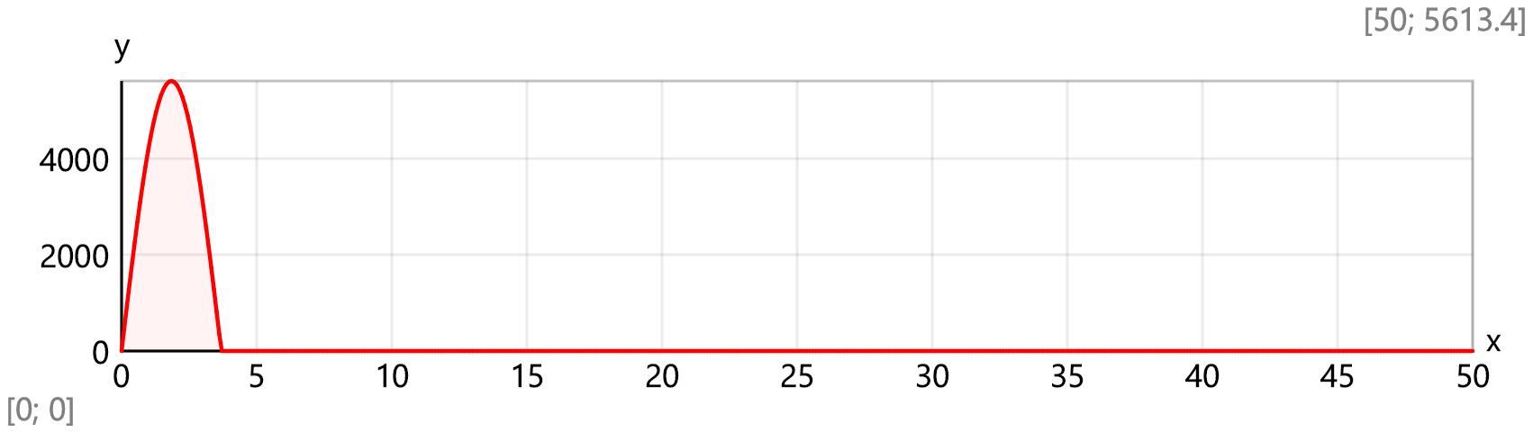
Maximal impulse load value - $F_{max}=F\left(\frac{τ_{L}}{2}\right)=F\left(\frac{3.69 \text{ms}}{2}\right)=5613.66 \text{kN}$
The equation of motion is expressed by the Duhamel′s integral
$$y_{D}\left(t\right)=\frac{1}{M_{tot}·ω_{1}}·\int_{0 \text{ms}}^{\text{min}\left(t;τ_{L}\right)}{F\left(τ\right)·e^{\text{-}ξ·ω_{1}·\left(t-τ\right)}·\text{sin}\left(ω_{1}·\left(t-τ\right)\right) dτ}$$
Static displacement for the midpoint of the beam
$$y_{0}\left(t\right)=z_{0}+\left(z_{st}-z_{0}\right)·\{\begin{matrix} if t<\frac{T_{1}}{4}: & \text{sin}\left(\frac{2·π·t}{T_{1}}\right) \\ else: & 1\end{matrix}$$
Time history of the midpoint displacement, [mm]
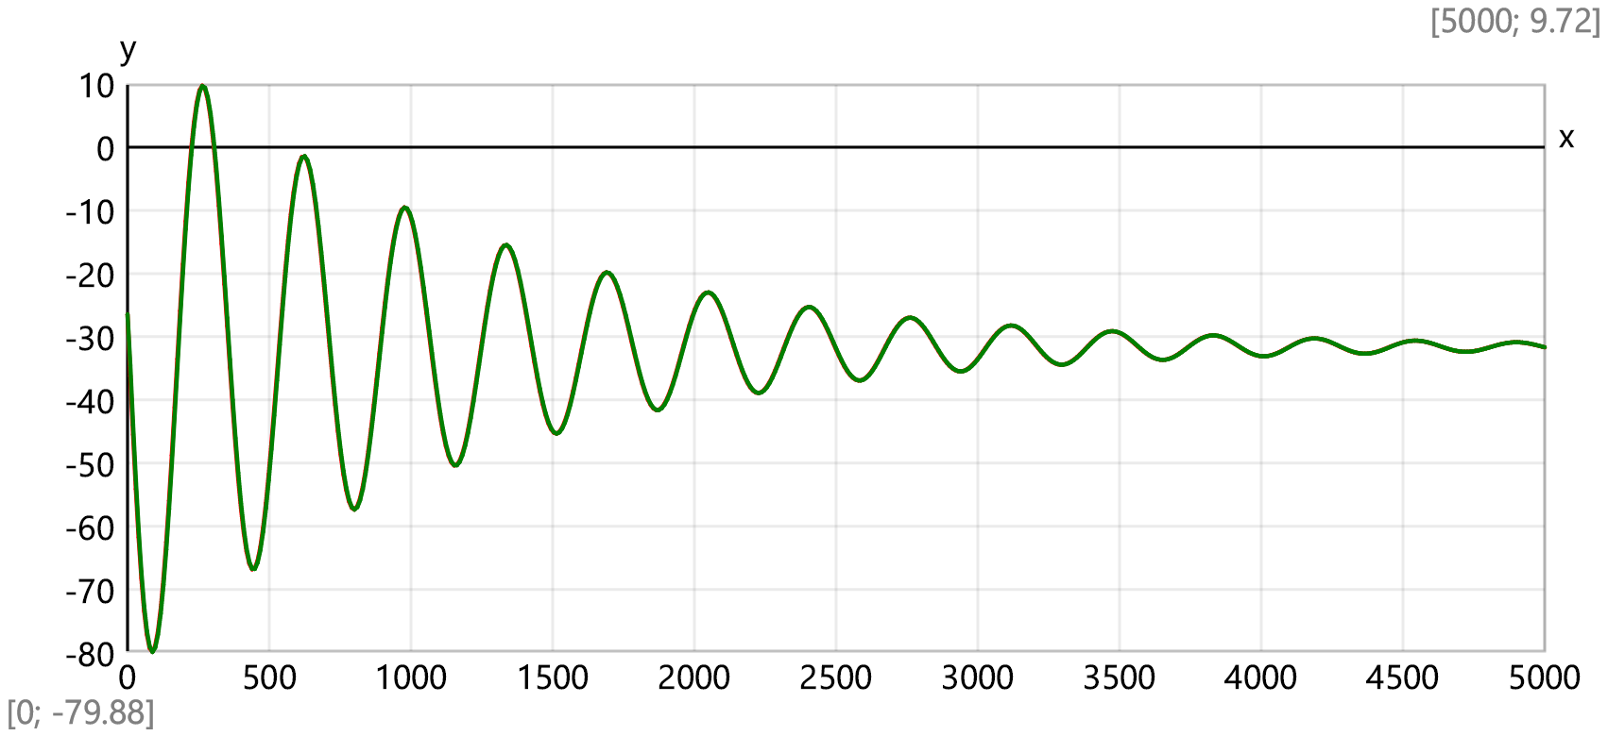
Elastic time history response of the structure as an MDOF system
Number of intermediate joints - $n_{J}=11$ (odd)
Length of one segment - $Δx=\frac{L}{n_{J}+1}=\frac{12 \text{m}}{11+1}=1 \text{m}$
Coordinate of joint j - $x_{J}\left(j\right)=Δx·j$
Shear forces due to unit vertical load F_{j} = 1 at joint j
$$V_{1}\left(x;j\right)=\{\begin{matrix} if x<x_{J}\left(j\right): & 1-\frac{x_{J}\left(j\right)}{L} \\ else: & \frac{\text{-}x_{J}\left(j\right)}{L}\end{matrix}$$
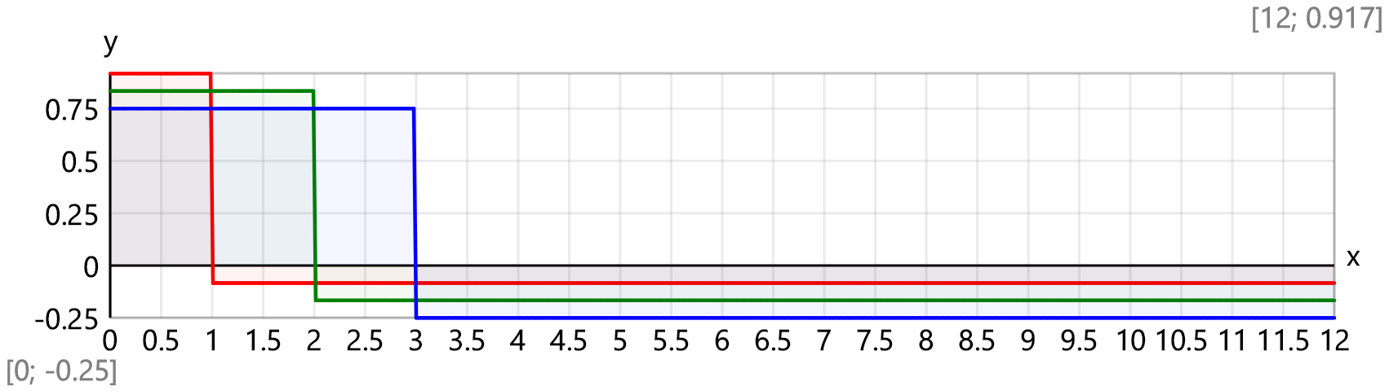
Bending moments due to unit vertical load F_{j} = 1 at joint j
$M_{1,max}\left(j\right)=\left(\frac{x_{J}\left(j\right)}{L}-1\right)·x_{J}\left(j\right)$, $M_{1}\left(x;j\right)=M_{1,max}\left(j\right)·\left(\{\begin{matrix} if x<x_{J}\left(j\right): & \frac{x}{x_{J}\left(j\right)} \\ else: & \frac{L-x}{L-x_{J}\left(j\right)}\end{matrix} \right)$
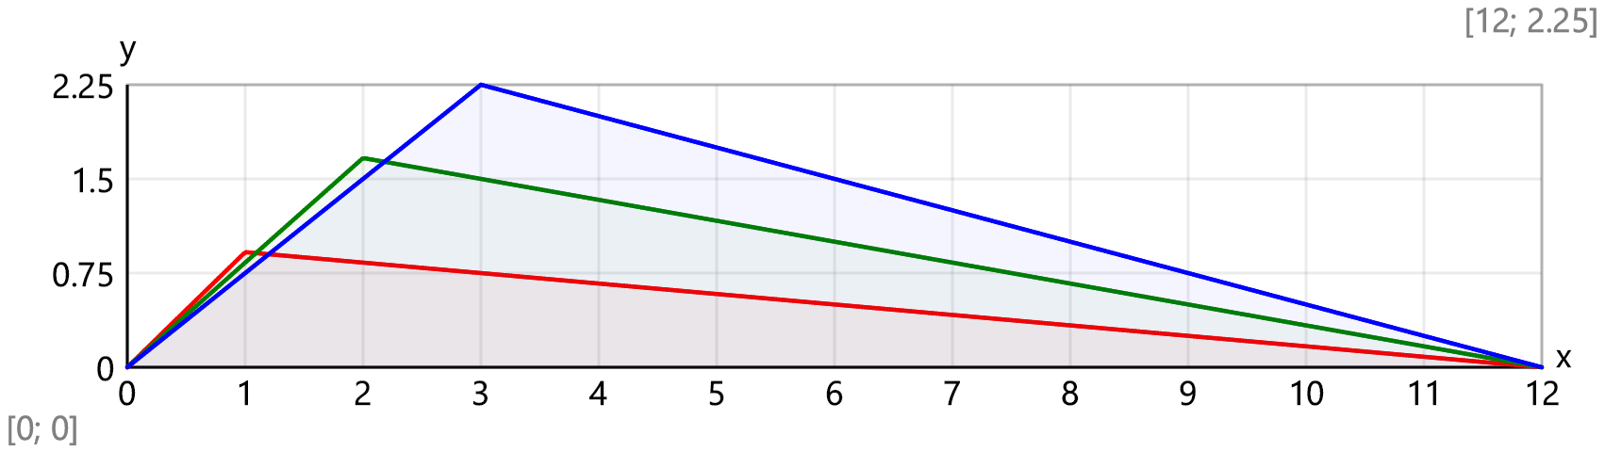
Flexibility matrix
$$D\left(i;j\right)=\left(\int_{0 \text{m}}^{L}{M_{1}\left(x;i\right)·M_{1}\left(x;j\right) dx}\right)·\frac{1}{E·I}+\left(\int_{0 \text{m}}^{L}{V_{1}\left(x;i\right)·V_{1}\left(x;j\right) dx}\right)·\frac{1}{G·A_{Q}}$$
$$D=$$
$\left[\begin{matrix}0.0216 & 0.0378 & 0.0489 & 0.0552 & 0.0574 & 0.056 & 0.0514 & 0.0443 & 0.035 & 0.0242 & ⋯ & 0.0124 \\ 0.0378 & 0.0704 & 0.093 & 0.106 & 0.111 & 0.109 & 0.1 & 0.0864 & 0.0685 & 0.0474 & ⋯ & 0.0242 \\ 0.0489 & 0.093 & 0.128 & 0.149 & 0.158 & 0.155 & 0.144 & 0.124 & 0.0988 & 0.0685 & ⋯ & 0.035 \\ 0.0552 & 0.106 & 0.149 & 0.179 & 0.193 & 0.193 & 0.18 & 0.156 & 0.124 & 0.0864 & ⋯ & 0.0443 \\ 0.0574 & 0.111 & 0.158 & 0.193 & 0.214 & 0.217 & 0.205 & 0.18 & 0.144 & 0.1 & ⋯ & 0.0514 \\ 0.056 & 0.109 & 0.155 & 0.193 & 0.217 & 0.227 & 0.217 & 0.193 & 0.155 & 0.109 & ⋯ & 0.056 \\ 0.0514 & 0.1 & 0.144 & 0.18 & 0.205 & 0.217 & 0.214 & 0.193 & 0.158 & 0.111 & ⋯ & 0.0574 \\ 0.0443 & 0.0864 & 0.124 & 0.156 & 0.18 & 0.193 & 0.193 & 0.179 & 0.149 & 0.106 & ⋯ & 0.0552 \\ 0.035 & 0.0685 & 0.0988 & 0.124 & 0.144 & 0.155 & 0.158 & 0.149 & 0.128 & 0.093 & ⋯ & 0.0489 \\ 0.0242 & 0.0474 & 0.0685 & 0.0864 & 0.1 & 0.109 & 0.111 & 0.106 & 0.093 & 0.0704 & ⋯ & 0.0378 \\ ⋮ & ⋮ & ⋮ & ⋮ & ⋮ & ⋮ & ⋮ & ⋮ & ⋮ & ⋮ & ⋱ & ⋮ \\ 0.0124 & 0.0242 & 0.035 & 0.0443 & 0.0514 & 0.056 & 0.0574 & 0.0552 & 0.0489 & 0.0378 & ⋯ & 0.0216\end{matrix}\right]$ mm/kN
Mass matrix
$$d_{M.j}=\frac{m·Δx}{ \text{t}}=\frac{1.6 \text{t}/ \text{m}·1 \text{m}}{ \text{t}}=1.6$$
$$M=\left[\begin{matrix}\text{1.6} & \text{0} & \text{0} & \text{0} & \text{0} & \text{0} & \text{0} & \text{0} & \text{0} & \text{0} & \text{⋯} & \text{0} \\ \text{0} & \text{1.6} & \text{0} & \text{0} & \text{0} & \text{0} & \text{0} & \text{0} & \text{0} & \text{0} & \text{⋯} & \text{0} \\ \text{0} & \text{0} & \text{1.6} & \text{0} & \text{0} & \text{0} & \text{0} & \text{0} & \text{0} & \text{0} & \text{⋯} & \text{0} \\ \text{0} & \text{0} & \text{0} & \text{1.6} & \text{0} & \text{0} & \text{0} & \text{0} & \text{0} & \text{0} & \text{⋯} & \text{0} \\ \text{0} & \text{0} & \text{0} & \text{0} & \text{1.6} & \text{0} & \text{0} & \text{0} & \text{0} & \text{0} & \text{⋯} & \text{0} \\ \text{0} & \text{0} & \text{0} & \text{0} & \text{0} & \text{3.7} & \text{0} & \text{0} & \text{0} & \text{0} & \text{⋯} & \text{0} \\ \text{0} & \text{0} & \text{0} & \text{0} & \text{0} & \text{0} & \text{1.6} & \text{0} & \text{0} & \text{0} & \text{⋯} & \text{0} \\ \text{0} & \text{0} & \text{0} & \text{0} & \text{0} & \text{0} & \text{0} & \text{1.6} & \text{0} & \text{0} & \text{⋯} & \text{0} \\ \text{0} & \text{0} & \text{0} & \text{0} & \text{0} & \text{0} & \text{0} & \text{0} & \text{1.6} & \text{0} & \text{⋯} & \text{0} \\ \text{0} & \text{0} & \text{0} & \text{0} & \text{0} & \text{0} & \text{0} & \text{0} & \text{0} & \text{1.6} & \text{⋯} & \text{0} \\ \text{⋮} & \text{⋮} & \text{⋮} & \text{⋮} & \text{⋮} & \text{⋮} & \text{⋮} & \text{⋮} & \text{⋮} & \text{⋮} & \text{⋱} & \text{⋮} \\ \text{0} & \text{0} & \text{0} & \text{0} & \text{0} & \text{0} & \text{0} & \text{0} & \text{0} & \text{0} & \text{⋯} & \text{1.6}\end{matrix}\right]$$
Total mass of the structure - $\text{sum}\left({\vec{d}}_{M}\right)=19.7$ t
Eigenvalues
$$M_{sq}=\sqrt{M}=\left[\begin{matrix}1.26 & 0 & 0 & 0 & 0 & 0 & 0 & 0 & 0 & 0 & ⋯ & 0 \\ 0 & 1.26 & 0 & 0 & 0 & 0 & 0 & 0 & 0 & 0 & ⋯ & 0 \\ 0 & 0 & 1.26 & 0 & 0 & 0 & 0 & 0 & 0 & 0 & ⋯ & 0 \\ 0 & 0 & 0 & 1.26 & 0 & 0 & 0 & 0 & 0 & 0 & ⋯ & 0 \\ 0 & 0 & 0 & 0 & 1.26 & 0 & 0 & 0 & 0 & 0 & ⋯ & 0 \\ 0 & 0 & 0 & 0 & 0 & 1.92 & 0 & 0 & 0 & 0 & ⋯ & 0 \\ 0 & 0 & 0 & 0 & 0 & 0 & 1.26 & 0 & 0 & 0 & ⋯ & 0 \\ 0 & 0 & 0 & 0 & 0 & 0 & 0 & 1.26 & 0 & 0 & ⋯ & 0 \\ 0 & 0 & 0 & 0 & 0 & 0 & 0 & 0 & 1.26 & 0 & ⋯ & 0 \\ 0 & 0 & 0 & 0 & 0 & 0 & 0 & 0 & 0 & 1.26 & ⋯ & 0 \\ ⋮ & ⋮ & ⋮ & ⋮ & ⋮ & ⋮ & ⋮ & ⋮ & ⋮ & ⋮ & ⋱ & ⋮ \\ 0 & 0 & 0 & 0 & 0 & 0 & 0 & 0 & 0 & 0 & ⋯ & 1.26\end{matrix}\right]$$
$$C=\text{copy}\left(M_{sq}·D·M_{sq};\text{symmetric}\left(n_{J}\right);1;1\right)=\text{copy}\left(M_{sq}·D·M_{sq};\text{symmetric}\left(11\right);1;1\right)$$
$$=\left[\begin{matrix}0.0345 & 0.0605 & 0.0781 & 0.0883 & 0.0918 & 0.136 & 0.0822 & 0.0708 & 0.056 & 0.0387 & ⋯ & 0.0198 \\ 0.0605 & 0.113 & 0.149 & 0.17 & 0.178 & 0.265 & 0.16 & 0.138 & 0.11 & 0.0758 & ⋯ & 0.0387 \\ 0.0781 & 0.149 & 0.204 & 0.238 & 0.252 & 0.378 & 0.23 & 0.199 & 0.158 & 0.11 & ⋯ & 0.056 \\ 0.0883 & 0.17 & 0.238 & 0.287 & 0.309 & 0.469 & 0.287 & 0.25 & 0.199 & 0.138 & ⋯ & 0.0708 \\ 0.0918 & 0.178 & 0.252 & 0.309 & 0.343 & 0.529 & 0.328 & 0.287 & 0.23 & 0.16 & ⋯ & 0.0822 \\ 0.136 & 0.265 & 0.378 & 0.469 & 0.529 & 0.839 & 0.529 & 0.469 & 0.378 & 0.265 & ⋯ & 0.136 \\ 0.0822 & 0.16 & 0.23 & 0.287 & 0.328 & 0.529 & 0.343 & 0.309 & 0.252 & 0.178 & ⋯ & 0.0918 \\ 0.0708 & 0.138 & 0.199 & 0.25 & 0.287 & 0.469 & 0.309 & 0.287 & 0.238 & 0.17 & ⋯ & 0.0883 \\ 0.056 & 0.11 & 0.158 & 0.199 & 0.23 & 0.378 & 0.252 & 0.238 & 0.204 & 0.149 & ⋯ & 0.0781 \\ 0.0387 & 0.0758 & 0.11 & 0.138 & 0.16 & 0.265 & 0.178 & 0.17 & 0.149 & 0.113 & ⋯ & 0.0605 \\ ⋮ & ⋮ & ⋮ & ⋮ & ⋮ & ⋮ & ⋮ & ⋮ & ⋮ & ⋮ & ⋱ & ⋮ \\ 0.0198 & 0.0387 & 0.056 & 0.0708 & 0.0822 & 0.136 & 0.0918 & 0.0883 & 0.0781 & 0.0605 & ⋯ & 0.0345\end{matrix}\right]$$
$$\vec{λ}=\text{reverse}\left(\text{last}\left(\text{eigenvals}\left(C·{10}^{\text{-}3}\right);7\right)\right)=\left[0.00261 0.000137 3.32\text{×}{10}^{\text{-}5} 9.33\text{×}{10}^{\text{-}6} 4.78\text{×}{10}^{\text{-}6} 2.17\text{×}{10}^{\text{-}6} 1.51\text{×}{10}^{\text{-}6}\right]$$
Natural circular frequences - $\vec{ω}=\sqrt{\frac{1}{\vec{λ}}}=\left[19.57 85.55 173.53 327.32 457.58 678.76 814.79\right]$ s⁻¹
Natural vibration frequences - $\vec{f}=\frac{\vec{ω}}{2·π}· \text{Hz}=\frac{\vec{ω}}{2·3.14}· \text{Hz}=\left[3.11 \text{Hz} 13.61 \text{Hz} 27.62 \text{Hz} 52.09 \text{Hz} 72.83 \text{Hz} 108.03 \text{Hz} 129.68 \text{Hz}\right]$
Natural vibration periods - $\vec{T}=\frac{1}{\vec{f}}=\left[0.321 \text{s} 0.0734 \text{s} 0.0362 \text{s} 0.0192 \text{s} 0.0137 \text{s} 0.00926 \text{s} 0.00771 \text{s}\right]$
Eigenvectors
$$Φ=\text{inverse}\left(M_{sq}\right)·{\text{extract}}_{cols}\left(\text{eigenvecs}\left(C·{10}^{\text{-}3}\right);\text{range}\left(n_{J};n_{J}-7+1;\text{-}1\right)\right)=\text{inverse}\left(M_{sq}\right)·{\text{extract}}_{cols}\left(\text{eigenvecs}\left(C·{10}^{\text{-}3}\right);\text{range}\left(11;11-7+1;\text{-}1\right)\right)$$
$$=\left[\begin{matrix}0.0752 & 0.161 & 0.217 & 0.28 & 0.301 & 0.323 & 0.309 \\ 0.145 & 0.28 & 0.319 & 0.28 & 0.186 & \text{-}9.74\text{×}{10}^{\text{-}13} & \text{-}0.113 \\ 0.206 & 0.323 & 0.252 & 2.84\text{×}{10}^{\text{-}13} & \text{-}0.187 & \text{-}0.323 & \text{-}0.266 \\ 0.253 & 0.28 & 0.0565 & \text{-}0.28 & \text{-}0.309 & 1.15\text{×}{10}^{\text{-}13} & 0.216 \\ 0.283 & 0.161 & \text{-}0.155 & \text{-}0.28 & \text{-}0.027 & 0.323 & 0.209 \\ 0.293 & 0 & \text{-}0.251 & \text{-}7.46\text{×}{10}^{\text{-}15} & 0.22 & 5.01\text{×}{10}^{\text{-}14} & \text{-}0.193 \\ 0.283 & \text{-}0.161 & \text{-}0.155 & 0.28 & \text{-}0.027 & \text{-}0.323 & 0.209 \\ 0.253 & \text{-}0.28 & 0.0565 & 0.28 & \text{-}0.309 & \text{-}2.16\text{×}{10}^{\text{-}13} & 0.216 \\ 0.206 & \text{-}0.323 & 0.252 & \text{-}2.77\text{×}{10}^{\text{-}13} & \text{-}0.187 & 0.323 & \text{-}0.266 \\ 0.145 & \text{-}0.28 & 0.319 & \text{-}0.28 & 0.186 & 1.09\text{×}{10}^{\text{-}12} & \text{-}0.113 \\ ⋮ & ⋮ & ⋮ & ⋮ & ⋮ & ⋮ & ⋮ \\ 0.0752 & \text{-}0.161 & 0.217 & \text{-}0.28 & 0.301 & \text{-}0.323 & 0.309\end{matrix}\right]$$
$$X=\text{stack}\left(\text{matrix}\left(1;3\right);Φ;\text{matrix}\left(1;3\right)\right)$$
$$=\left[\begin{matrix}0 & 0 & 0 & 0 & 0 & 0 & 0 \\ 0.0752 & 0.161 & 0.217 & 0.28 & 0.301 & 0.323 & 0.309 \\ 0.145 & 0.28 & 0.319 & 0.28 & 0.186 & \text{-}9.74\text{×}{10}^{\text{-}13} & \text{-}0.113 \\ 0.206 & 0.323 & 0.252 & 2.84\text{×}{10}^{\text{-}13} & \text{-}0.187 & \text{-}0.323 & \text{-}0.266 \\ 0.253 & 0.28 & 0.0565 & \text{-}0.28 & \text{-}0.309 & 1.15\text{×}{10}^{\text{-}13} & 0.216 \\ 0.283 & 0.161 & \text{-}0.155 & \text{-}0.28 & \text{-}0.027 & 0.323 & 0.209 \\ 0.293 & 0 & \text{-}0.251 & \text{-}7.46\text{×}{10}^{\text{-}15} & 0.22 & 5.01\text{×}{10}^{\text{-}14} & \text{-}0.193 \\ 0.283 & \text{-}0.161 & \text{-}0.155 & 0.28 & \text{-}0.027 & \text{-}0.323 & 0.209 \\ 0.253 & \text{-}0.28 & 0.0565 & 0.28 & \text{-}0.309 & \text{-}2.16\text{×}{10}^{\text{-}13} & 0.216 \\ 0.206 & \text{-}0.323 & 0.252 & \text{-}2.77\text{×}{10}^{\text{-}13} & \text{-}0.187 & 0.323 & \text{-}0.266 \\ ⋮ & ⋮ & ⋮ & ⋮ & ⋮ & ⋮ & ⋮ \\ 0 & 0 & 0 & 0 & 0 & 0 & 0\end{matrix}\right]$$
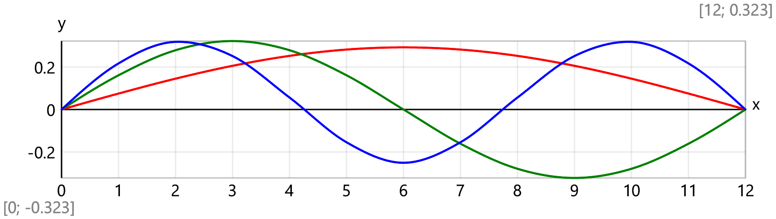
Modal masses - ${\vec{m}}_{Φ}=\text{diag2vec}\left(\text{transp}\left(Φ\right)·M·Φ\right)· \text{t}=\left[1 \text{t} 1 \text{t} 1 \text{t} 1 \text{t} 1 \text{t} 1 \text{t} 1 \text{t}\right]$
Rayleigh damping model is assumed
$β=\frac{2·ξ}{{\vec{ω}}_{1}+{\vec{ω}}_{2}}=\frac{2·0.05}{19.57+85.55}=0.000951$ , $α=β·{\vec{ω}}_{1}·{\vec{ω}}_{2}=0.000951·19.57·85.55=1.59$
$$ξ\left(ω\right)=\frac{α}{2·ω}+\frac{β·ω}{2}$$
Modal damping factors - ${\vec{ξ}}_{Φ}=ξ\left(\vec{ω}\right)=\left[0.05 0.05 0.0871 0.158 0.219 0.324 0.389\right]$
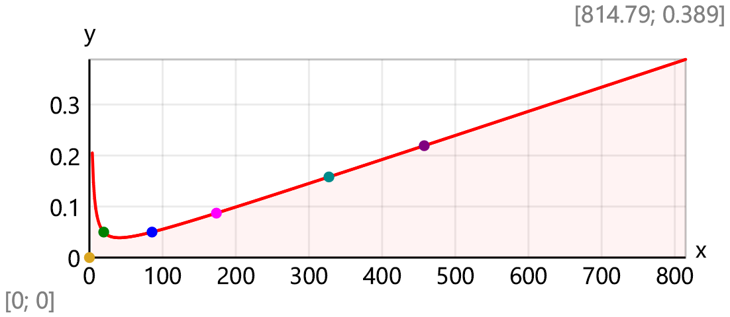
Damped natural frequences
$${\vec{ω}}_{D}=\vec{ω}·\sqrt{1-{\vec{ξ}}_{Φ}^2}·{ \text{s}}^{\text{-}1}=\left[19.54{ \text{s}}^{-1} 85.44{ \text{s}}^{-1} 172.87{ \text{s}}^{-1} 323.2{ \text{s}}^{-1} 446.43{ \text{s}}^{-1} 642.14{ \text{s}}^{-1} 750.77{ \text{s}}^{-1}\right]$$
Dynamic load vector
$$F_{Φ}\left(i;t\right)=Φ_{j_{m},i}·F\left(t\right)$$
The equations of modal dynamic displacements are expressed by the Duhamel′s integral
$$y_{Φ}\left(i;t\right)=\frac{1}{{{\vec{m}}_{Φ}}_{.i}·{ω_{D}}_{.i}}·\int_{0 \text{ms}}^{\text{min}\left(t;τ_{L}\right)}{F_{Φ}\left(i;τ\right)·e^{\text{-}{{\vec{ξ}}_{Φ}}_{.i}·{\vec{ω}}_{i}·s^{\text{-}1}·\left(t-τ\right)}·\text{sin}\left({ω_{D}}_{.i}·\left(t-τ\right)\right) dτ}$$
Joint displacements
$$y_{J}\left(j;t\right)=\sum_{i=1}^{7}{Φ_{j,i}·y_{Φ}\left(i;t\right)}$$
Comparison of time history records of the midpoint displacements for SDOF and MDOF systems, [mm]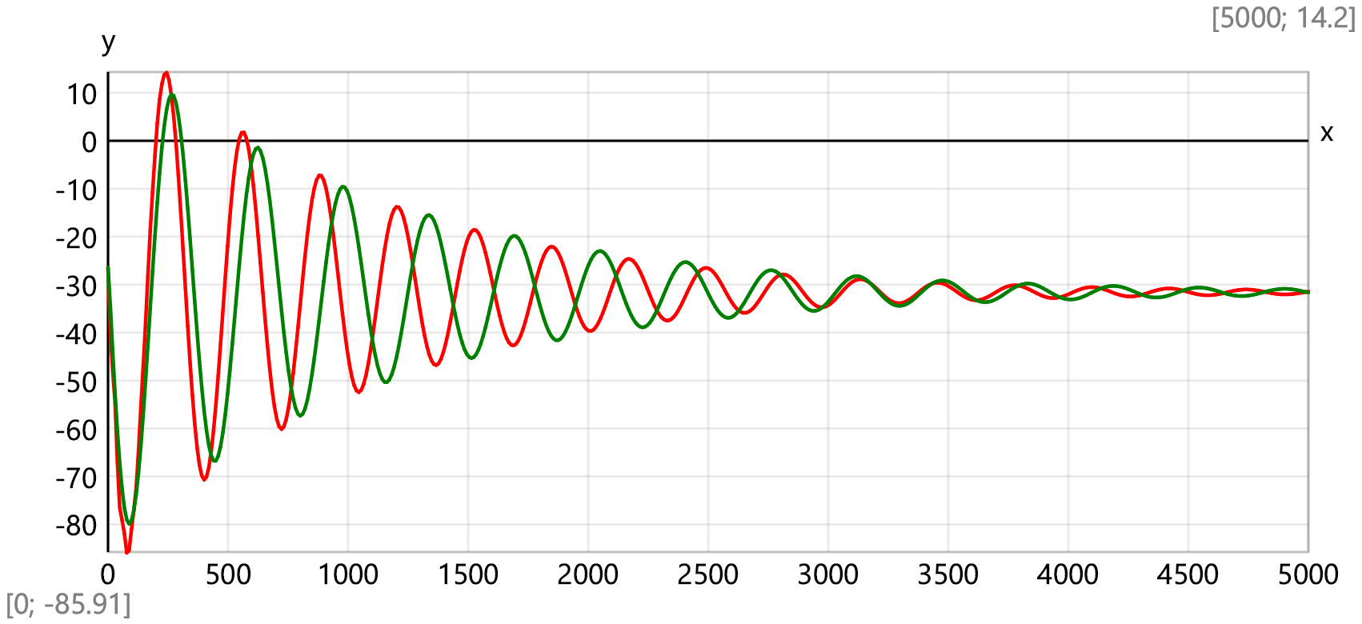
Time history records for the amplitudes of separate joints, [mm]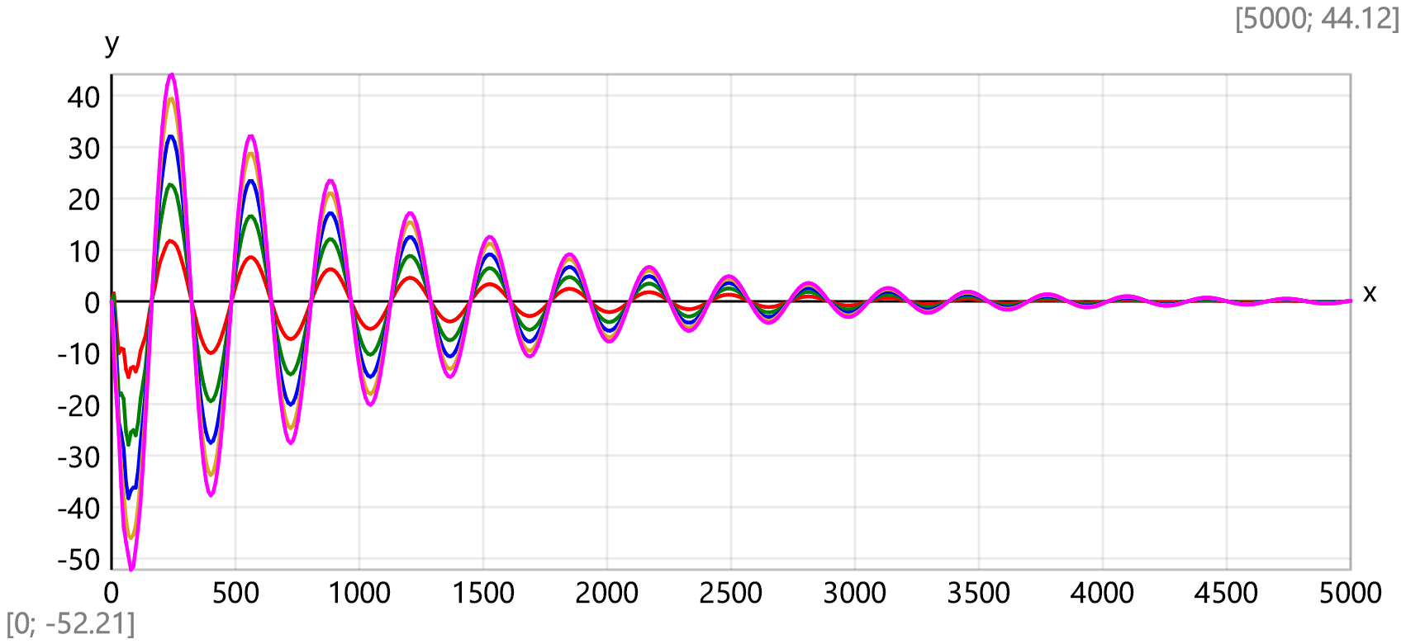
Beam deflections [mm] for the first five time steps at Δt = 17.7 ms
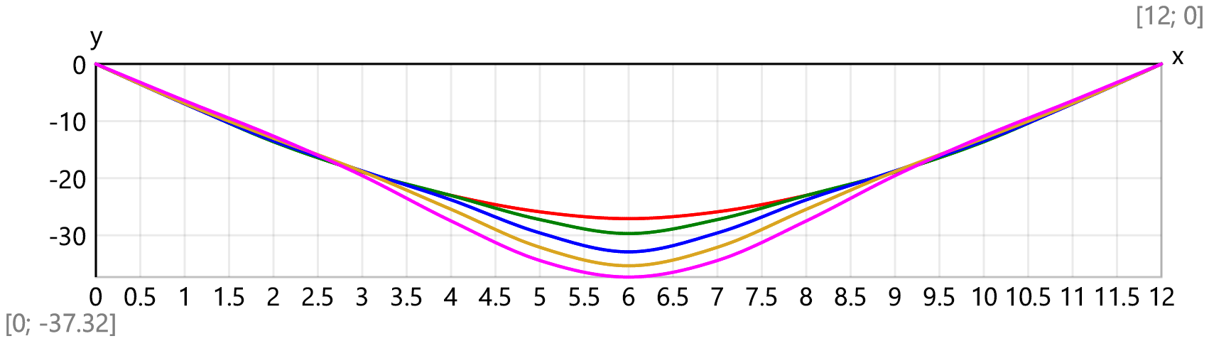
[1] Harris C. M., Piersol A.G., HARRIS’ SHOCK AND VIBRATION HANDBOOK, Fifth Edition, McGraw-Hill 2002, ISBN 0-07-137081-1
[2] Qing Peng, Xiaoming Liu, Yueguang Wei, Elastic impact of sphere on large plate, Journal of the Mechanics and Physics of Solids, Volume 156, 2021, 104604, ISSN 0022 - 5096, https://doi.org/10.1016/j.jmps.2021.104604
[3] Hong Hao and Thong M. Pham, Performance of RC Beams with or without FRP Strengthening Subjected to Impact Loading, Proceedings of the 2nd World Congress on Civil, Structural, and Environmental Engineering (CSEE’17) Barcelona, Spain – April 3– 4, 2017 ISSN:2371 - 5294 DOI:10.11159/icsenm17.1
[4] Gugan, D. “Inelastic collision and the Hertz theory of impact.” American Journal of Physics 68 (2000): 920-924., http://www.oxfordcroquet.com/tech/gugan/index.asp

